**Lab 1 – AIDI 2004**

Faizan Ali(100518916)

**Step 1**

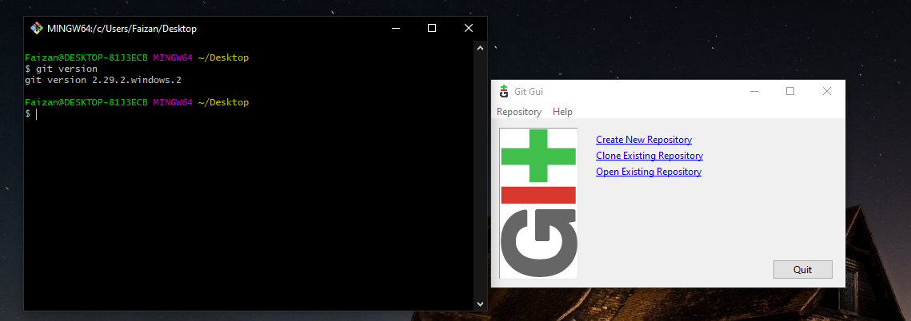

**Step 2**

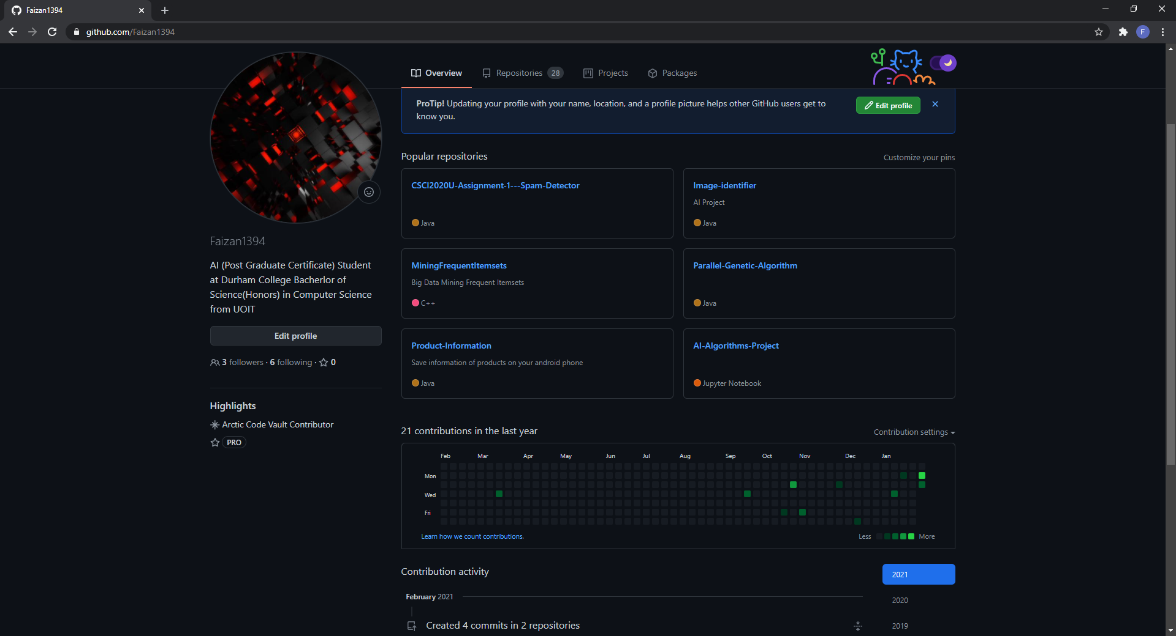

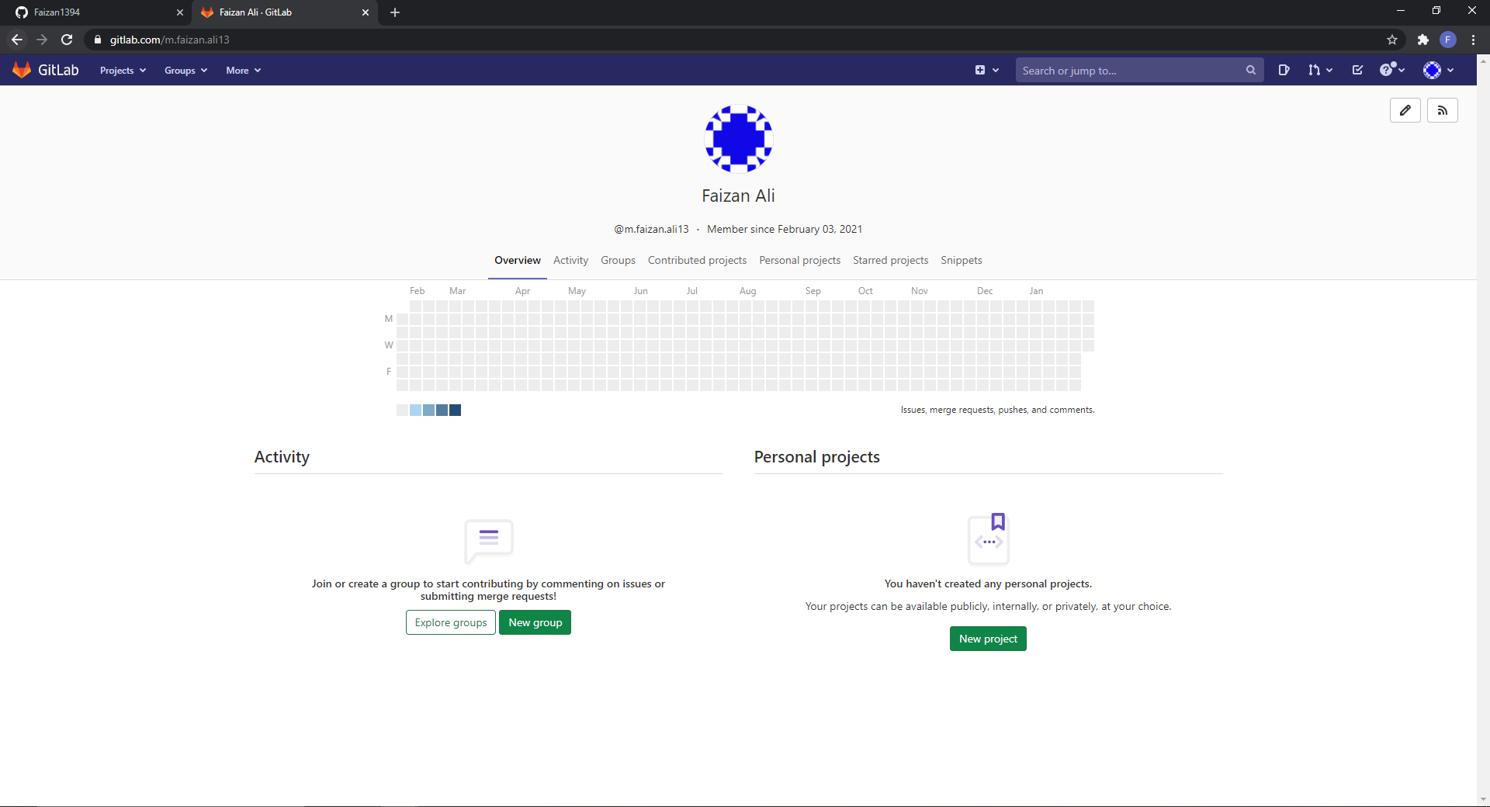

**Step 3 GitHub vs GitLab**

After researching both GitHub and GitLab I ended up choosing to use GitHub.

* GitHub has been available for a lot longer which means it has a bigger userbase and very little bugs if any.
* I have been personally using GitHub for a few years now so I am very well familiar with it
* GitHub free account only allows you to create Public repositories and not Private unless you pay, but that is more than sufficient for the purpose of school projects which I plan on public anyways to build my portfolio.
* I find the GitHub Desktop app very easy to use as an alternative to using git commands from time to time when doing things like creating a new repository or just wanting to visualize my commits.

**Step 4**

Python program written in Jupyter Notebook available on GitHub(simpleProgram branch). Description in readme.md file

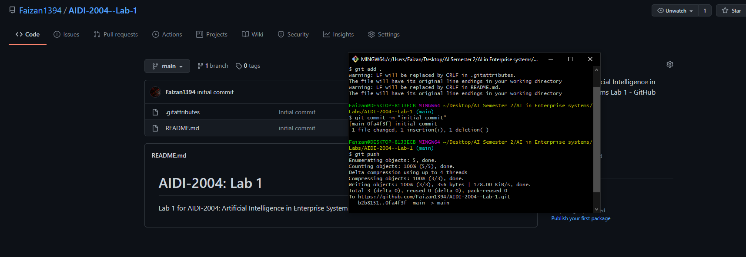**Step 5**

**Step 6**

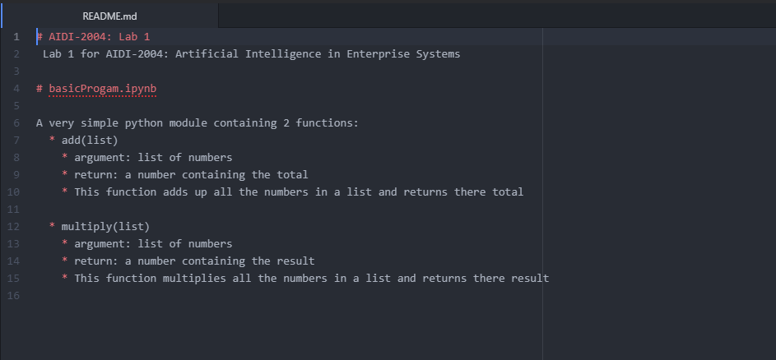

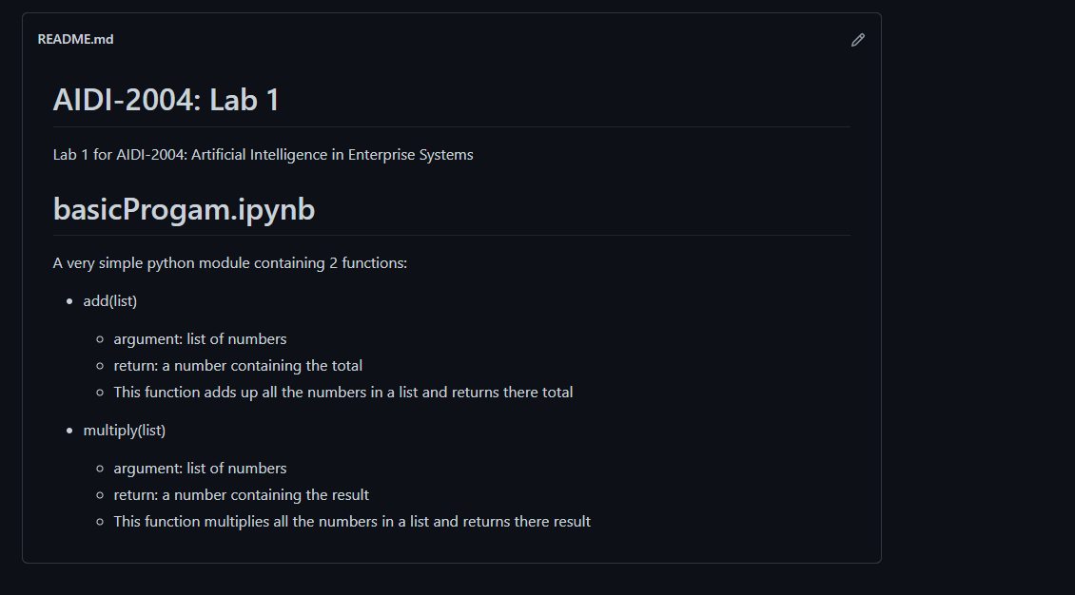

**Step 7**

New branch created using the command “git branch simpleProgram” in git

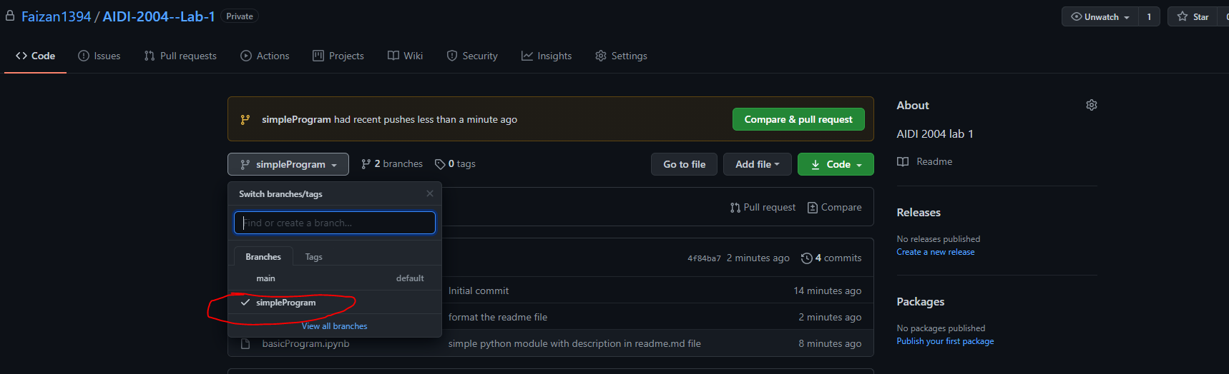

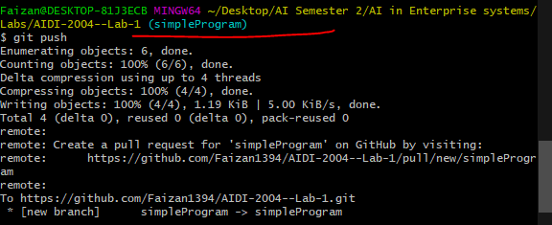

**Step 8**

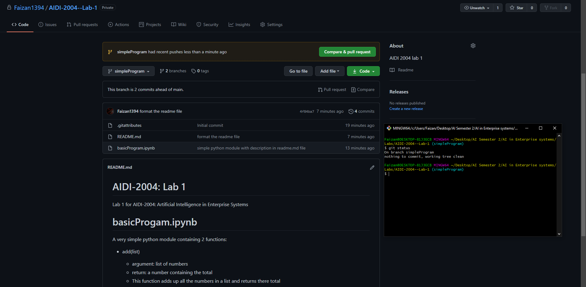

**Step 9**

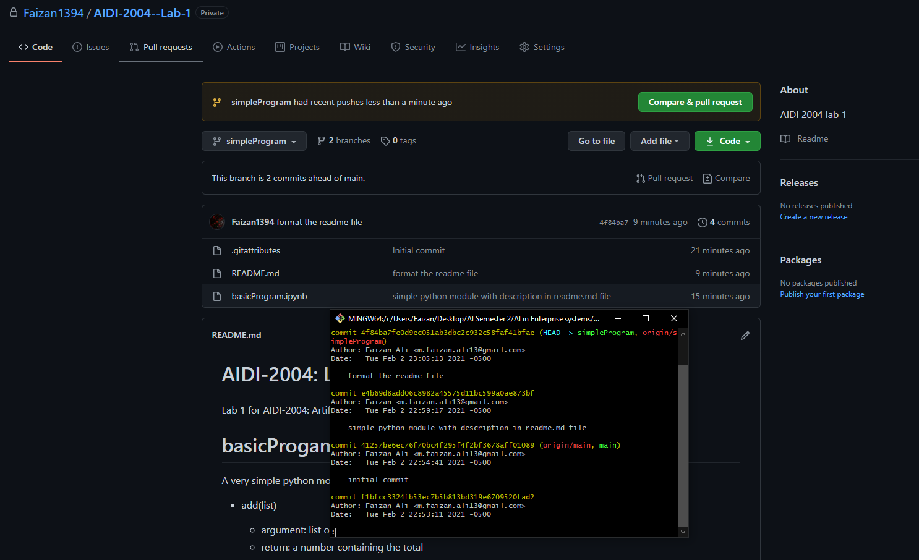

**Step 10**

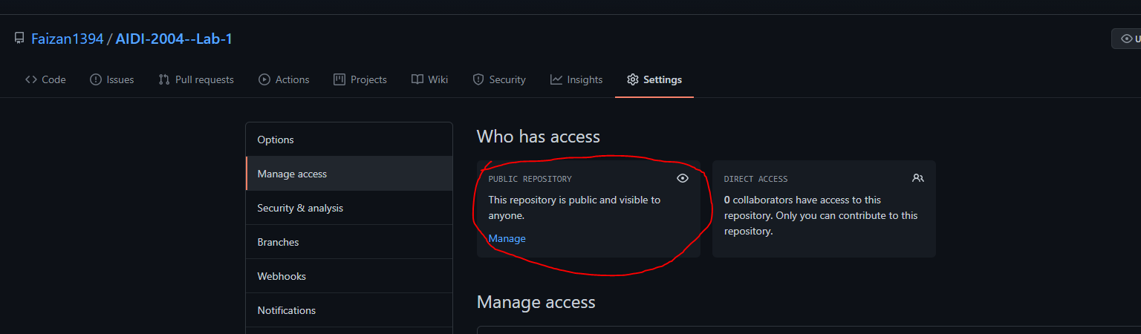

Link: https://github.com/Faizan1394/AIDI-2004--Lab-1